**Garbage Monitoring System**

**Design project for DS302 submitted by-**

**Group- 29**

1. Amit Sharma- 2011016

2.Praveen Sharma- 2011209

3.Deepak Kapoor- 2011189

4.Saurabh Joshi -2011259

5.Ratna Prakirana- 2011211

6. Chhattlal Sahu- 2011042

Supervisor

Dr. M. Amarnath

Mr. K.K.Bala



**PDPM INDIAN INSTITUTE OF INFORMATION TECHNOLOGY, DESIGN AND MANUFACTURING JABALPUR**

**CONTENTS:-**

1. Contents………………………………………………………2

2. Acknowledgement…………………………………………… 3

3. Abstract ……………………………………………………....3

4. Introduction…………………………………………………...4

5. Objective ……………………………………………………..4

6. Mission Statement…………………………………………….4

7. Current Product Specification………………………………...4

8. Concept Generation…………………………………………...5

9. Concept Selection……………………………………………..9

10. Concept Evaluation…………………………………………10

11. Embodiment Design………………………………………..13

12. Cost Analysis……………………………………………….26

13. Prototype …………………………………………………..30

14. Result……………………………………………………....37

15. Conclusion…………………………………………………38

16. Appendices………………………………………………...38

17. Vendors ……………………………………………………39

Acknowledgement

Express my deep sense of gratitude towards DS 302 Course instructors; Dr. M.Amarnath and Mr.K.K.Bala for their valuable guidance, moral support and constant encouragement throughout the duration of the project. Their approach to design, documentation and presentation will always be a valuable learning experience for us. Their dedication, professionalism and hard work have been and shall be a source of inspiration throughout our lives. We must thank our TAs who guided us during whole design process .we thank the design fraternity at IIITDM-Jabalpur.

Amit Sharma- 2011016

Praveen Sharma- 2011209

Deepak Kapoor- 2011189

Saurabh Joshi -2011259

Ratna Prakirana- 2011211

Chhattlal Sahu- 2011042

**Abstract:-**

In this project we have tried to solve the problem of overflowing of garbage from the locality dustbin. The overflowing of garbage causes various problems around the surrounding areas. After looking at various possible solution we have arrive at a conclusion to prevent overflowing of garbage by using electronics system. We have looked at all the pros and cons of this concept and have developed the detailed design report for the same.

**Introduction:-**

Here we are solving a social problem overflowing of garbage from garbage bin which normally can be seen in localities, nearby places it causes many health related problem and damage to environment. By designing suitable garbage bin along with electronics trying to reduce the problem.

**Aim:-** To design a system to prevent overflowing of garbage and making dustbin more user-friendly.

**Objective:-** To study various design of locality dustbin available in localities.

To study various pros and cons of the dustbin available in locality.

To design a system which can prevent overflowing of garbage and make more user-friendly.

**Mission statement:-**

Garbage Monitoring System in localities.

Improving the functionality of Garbage Container or bin located in colonies.

Functionality here refers to efficient collection of garbage from the bins in proper time.

Solutions to the other problems related to these bins as specified by the public and make human interaction simple.

**Product specification:-**

1. Basket of garbage bin should open when person comes in vicinity.
2. When garbage bin gets full, responsible person must come to know about this.
3. If garbage does not dump with in time then, higher authority should get informed. So appropriate action can be for garbage dumping.
4. Rainy water should not mix with garbage
5. Garbage should not be spilled out by street animal.
6. Easy opening of basket for throwing of garbage.

7. Circuit should be prevented from heat.

8. Easy to maintain.

**Concept generation:-**

**Concept-1:-**

1. Sensors are used for opening instruction.
2. Rack and pinion system is used for opening the window dustbin by help of motor.
3. Sensor and GSM module are used for alert system.
4. Automatic open

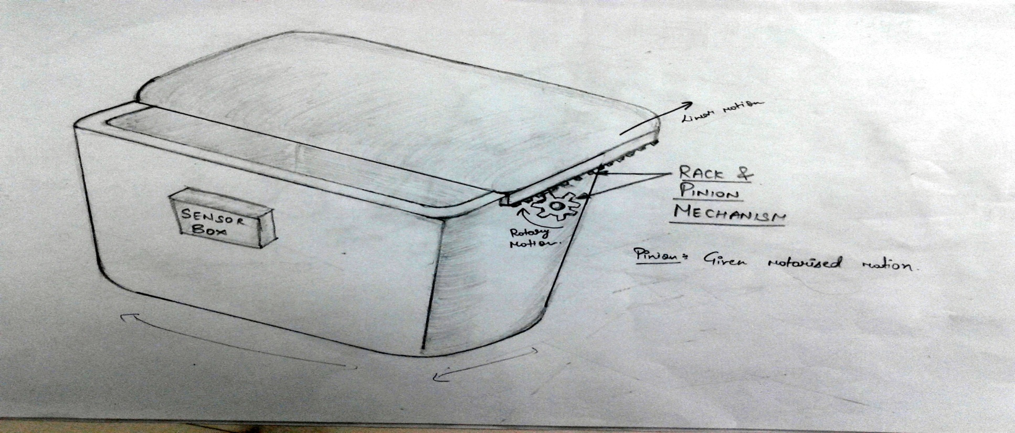

Fig.1

**Concept-2:**

1. Paddle and chain system are used for opening of window of bin.
2. Sensor and GSM module are used for alert system.
3. Manual opening for bin.

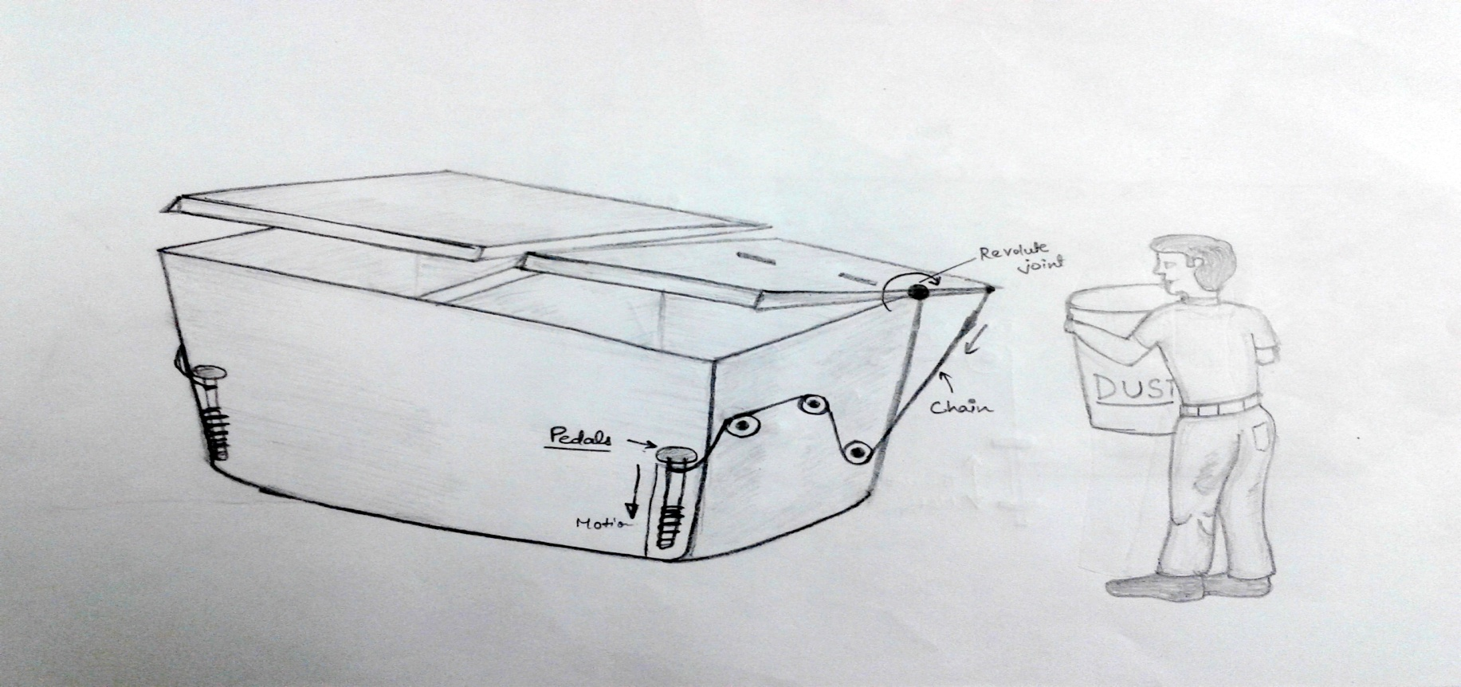

**Fig.2**

**Concept-3:-**

1. Flipper is used as window of garbage bin.
2. All other function are same as existing garbage bin.
3. Sensor and GSM module are used for alert system.

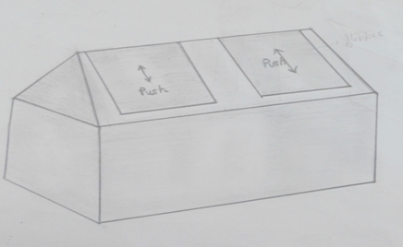

**Fig.3**

**Concept-4:-**

1. Vertical flipper is used to throw the garbage in bin.
2. Fixed basket is provided in front of flipper, garbage will be thrown in this basket and by garbage will slide on basket slope and hit flipper, flipper is free to rotate. It will open and through it garbage will move inside the bin.
3. Sensor and GSM module is used for alert system.

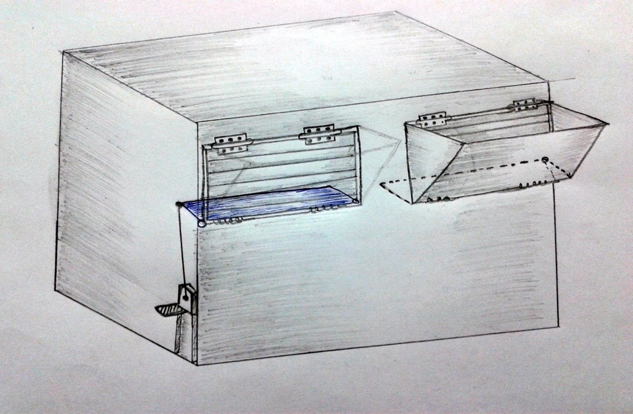

**Fig.4**

**Concept-5:-**

1. Two basket type of window are used as window by which garbage can be thrown inside the garbage bin.
2. 4 bar linkage are used for opening of window.
3. Motor is used for crank rotation of 4 bar linkage.
4. In case of power failure. Lever is provided for opening of window.
5. Sensors and GSM modules are used for alert system that bin is full.

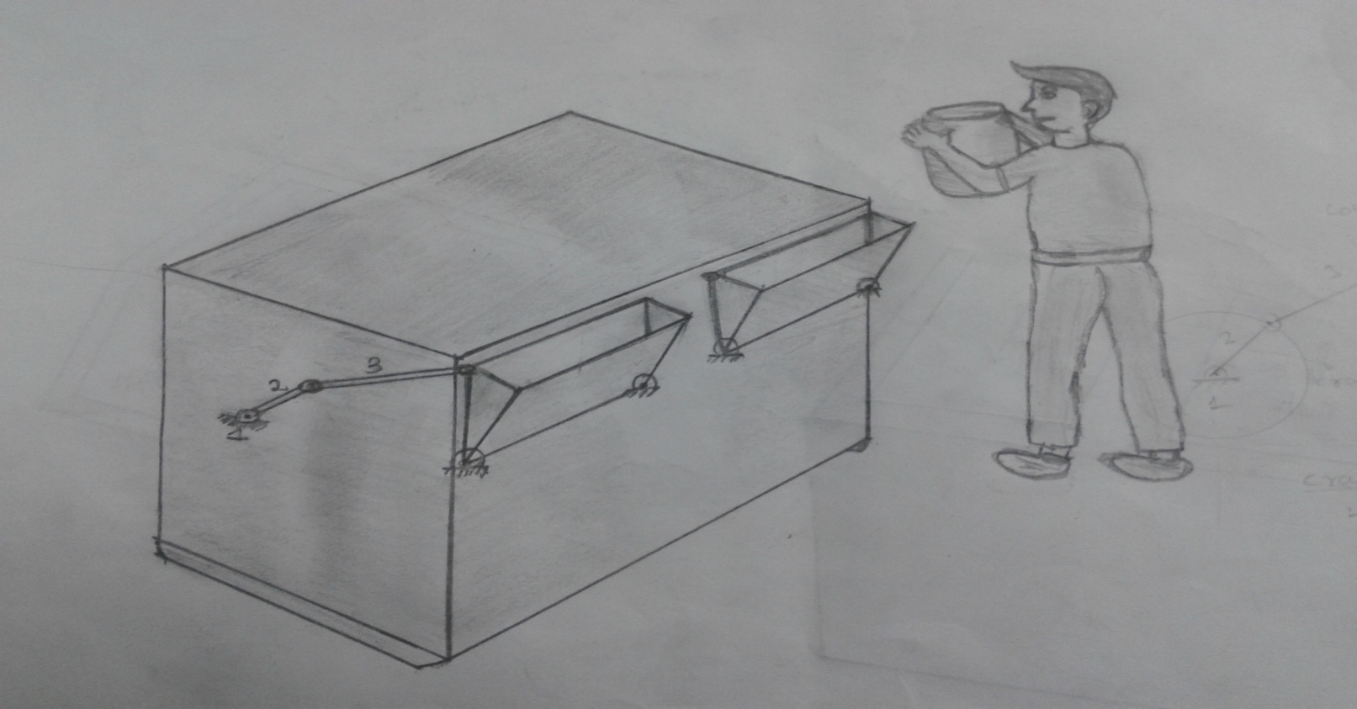

**Fig.5**

|  |  |  |  |  |  |  |
| --- | --- | --- | --- | --- | --- | --- |
| **S no** | **Parameter** | **Concept1** | **Concept2** | **Concept3** | **Concept4** | **Concept5** |
| **1** | **Functionality** | **4** | **3** | **3** | **4** | **5** |
| **2** | **Power** | **3** | **5** | **4** | **4** | **3** |
| **3** | **Water preventive** | **4** | **2** | **2** | **4** | **5** |
| **4** | **Easy to use** | **4** | **2** | **3** | **3** | **5** |
| **5** | **Cost** | **4** | **4** | **5** | **3** | **3** |
| **6** | **Total** | **19** | **16** | **17** | **18** | **21** |

**Concept selection(rating,max=5,min=0):-**

**Concept Evaluation:-**

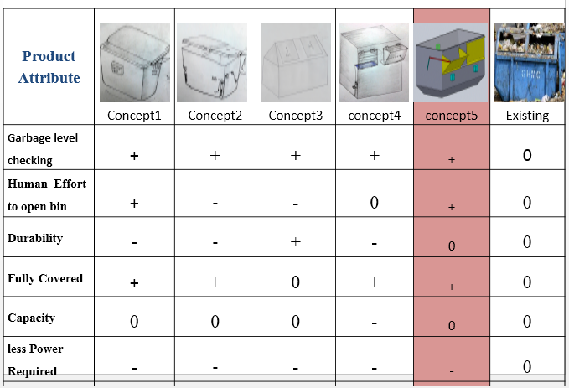

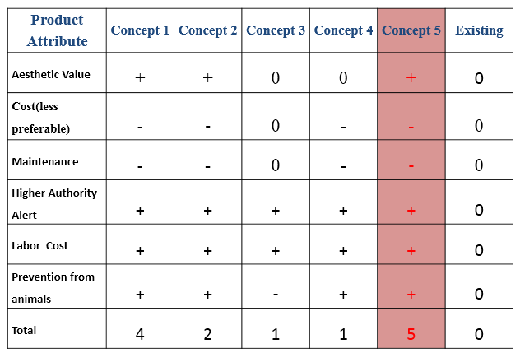

**Flow chart:-**

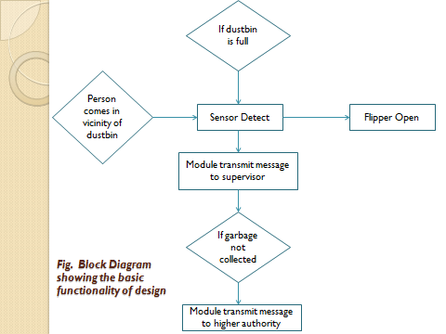

**Embodiment Design:-**

**Product Architecture:-**

|  |  |  |
| --- | --- | --- |
| **S. NO.** | **COMOPNENTS** | **FUNCTION** |
| 1. | Container | Use for garbage collection |
| 2. | Container’s roof | Use for covering |
| 3. | Basket | Opening and closing of garbage bin,  To throw garbage |
| 4. | 4-bar linkage | Mechanism for opening and closing of window |
| 5. | Geared Motor | To operate 4 bar linkage |
| 6. | Handle | To open Basket in case of power failure |
| 7. | Hinges | For rotary motion. |
| 8. | Bearing | Reduce friction between linkage |
| 9. | Gate locking pin | For lock the back door |
| 10. | At mega -16(micro controller) | For controlling various activity |
| 11. | Back door | For taking out garbage |
| 12. | Max-232(TTL logic convertor) | TTL Logic converter |
| 13. | Gsm Module | For transmitting message |
| 14. | IR Sensor | For checking Garbage is full or not |
| 15. | Tsop Sensor module | To check vicinity of human |
| 16. | L298 (motor driver) | To drive motor |
| 17. | 7805 (Power regulator) | Power Regulator |
| 18. | resistor and capacitor (.1Uf) | Parts of circuit |
| 19. | Fecl3 | For etching |
| 20. | Printed circuit board | To Print the circuit |
| 21. | Adapter12V | For supplying power to circuit. |
| 22. | Li-ion cell | For circuit operating |

**Standard Parts:-**

1. Bearings
2. Hinges
3. Rivets
4. Motor
5. GSM module
6. Microcontroller
7. IR sensor
8. Tsop sensor module
9. Resistor
10. Capacitor
11. Printed circuit board
12. adapter

**Manufacturing parts:-**

1. Garbage bin
2. Basket
3. 4-bar linkage

**Material Specification:-**

**Garbage bin:-**

|  |  |  |  |  |
| --- | --- | --- | --- | --- |
| S.No. | Material | Strength  (ultimate tensile stress)(N/mm2) | Cost  (per  kg) | properties |
| 1. | GI (1.5mm thick)(Galvanized iron)sheet | 420 | 45 | More stiff, ductile |
| 2. | Mild steel | 350 | 25 | Less cost, brittle |
| 3. | Stainless steel | 860 | 76 | More stiff, ductile |
|  |  |  |  |  |

**Basket and links:-**

|  |  |  |  |  |
| --- | --- | --- | --- | --- |
| S.no. | Material | Strength  (ultimate tensile stress)(N/mm2) | Cost(per kg) | advantages |
| 1. | Aluminium sheet (5mm thick) | 228 | 45 | Light weight, less torque require for opening |
| 2. | GI (Galvanized iron)sheet | 420 | 45 | More stiff |

**Material selection:-**

|  |  |  |  |
| --- | --- | --- | --- |
| S.No. | Components | Standard parts(Y/N) | Material |
| 1. | Garbage bin | N | GI sheet |
| 2. | Basket | N | Aluminium (5052-H32) |
| 3. | Links | N | Aluminium (5052-H32) |
| 4. | Side door | N | GI sheet |
| 5. | Locking pin | N | Mild steel |
| 6. | Rivets | Y | Mild steel |
| 7. | Hinges | Y | Stainless steel |
| 8. | Nut &bolt | Y | Mild steel |

**Parametric Design:-**

**Container:-**

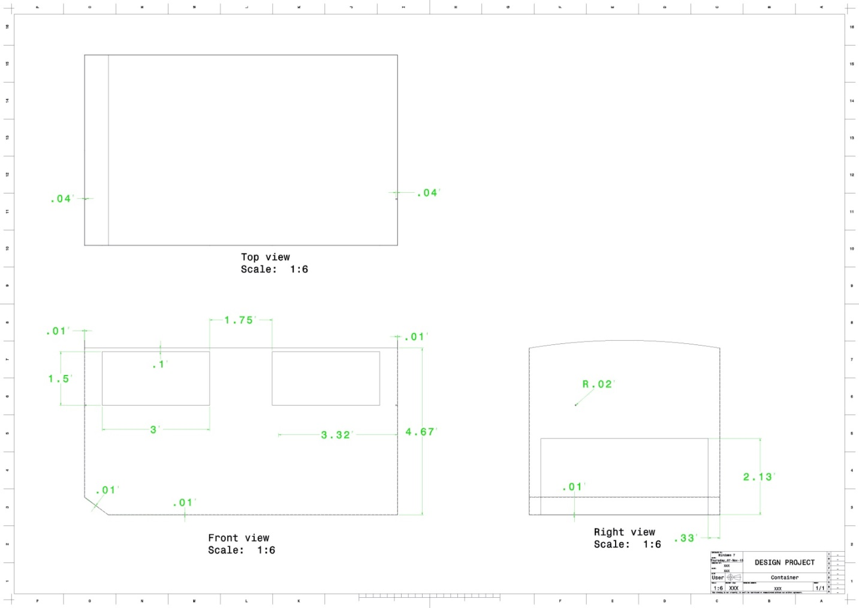

**Coupler:-**

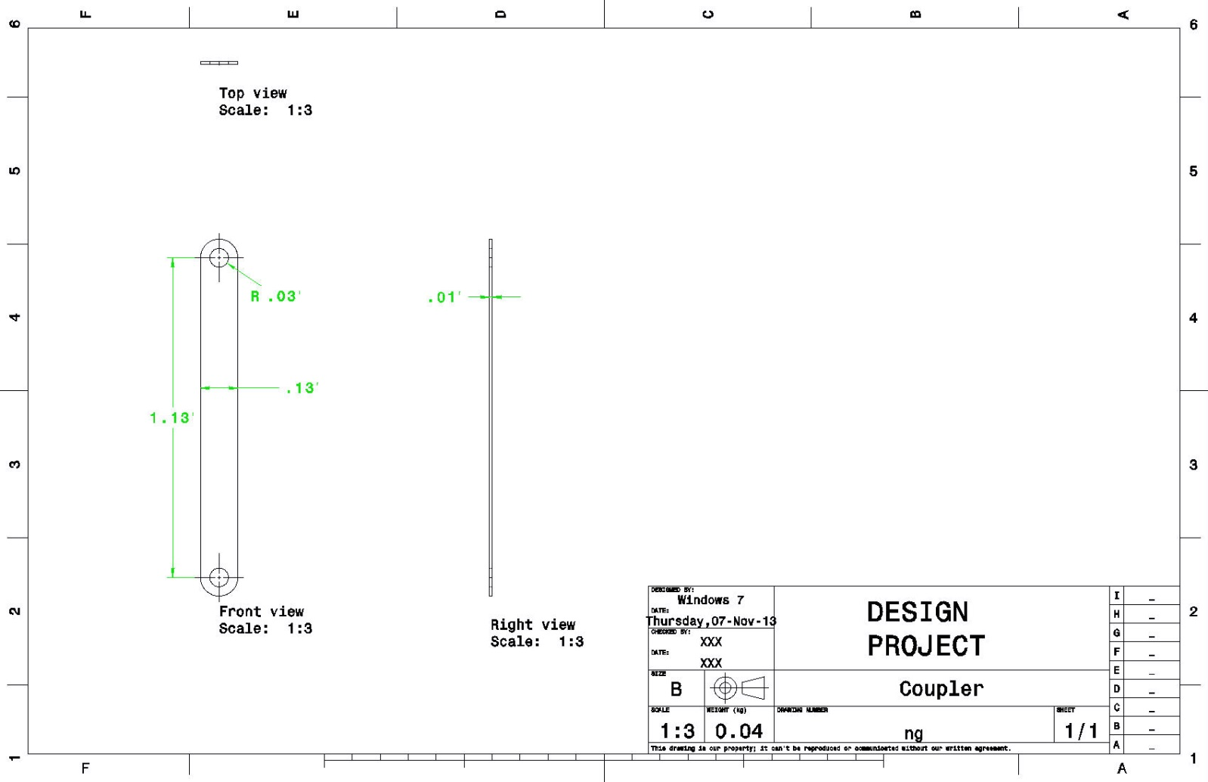

**Crank:-**

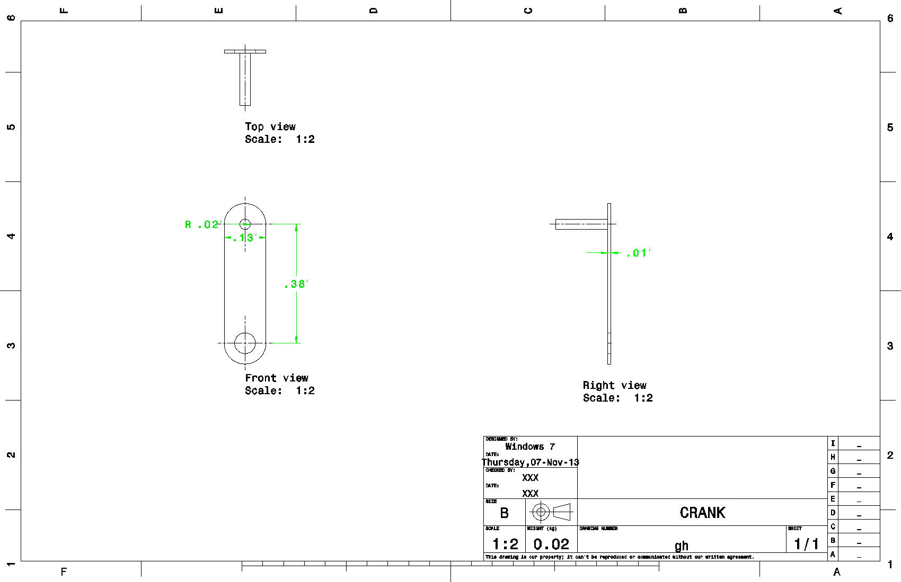

**Left Basket:-**

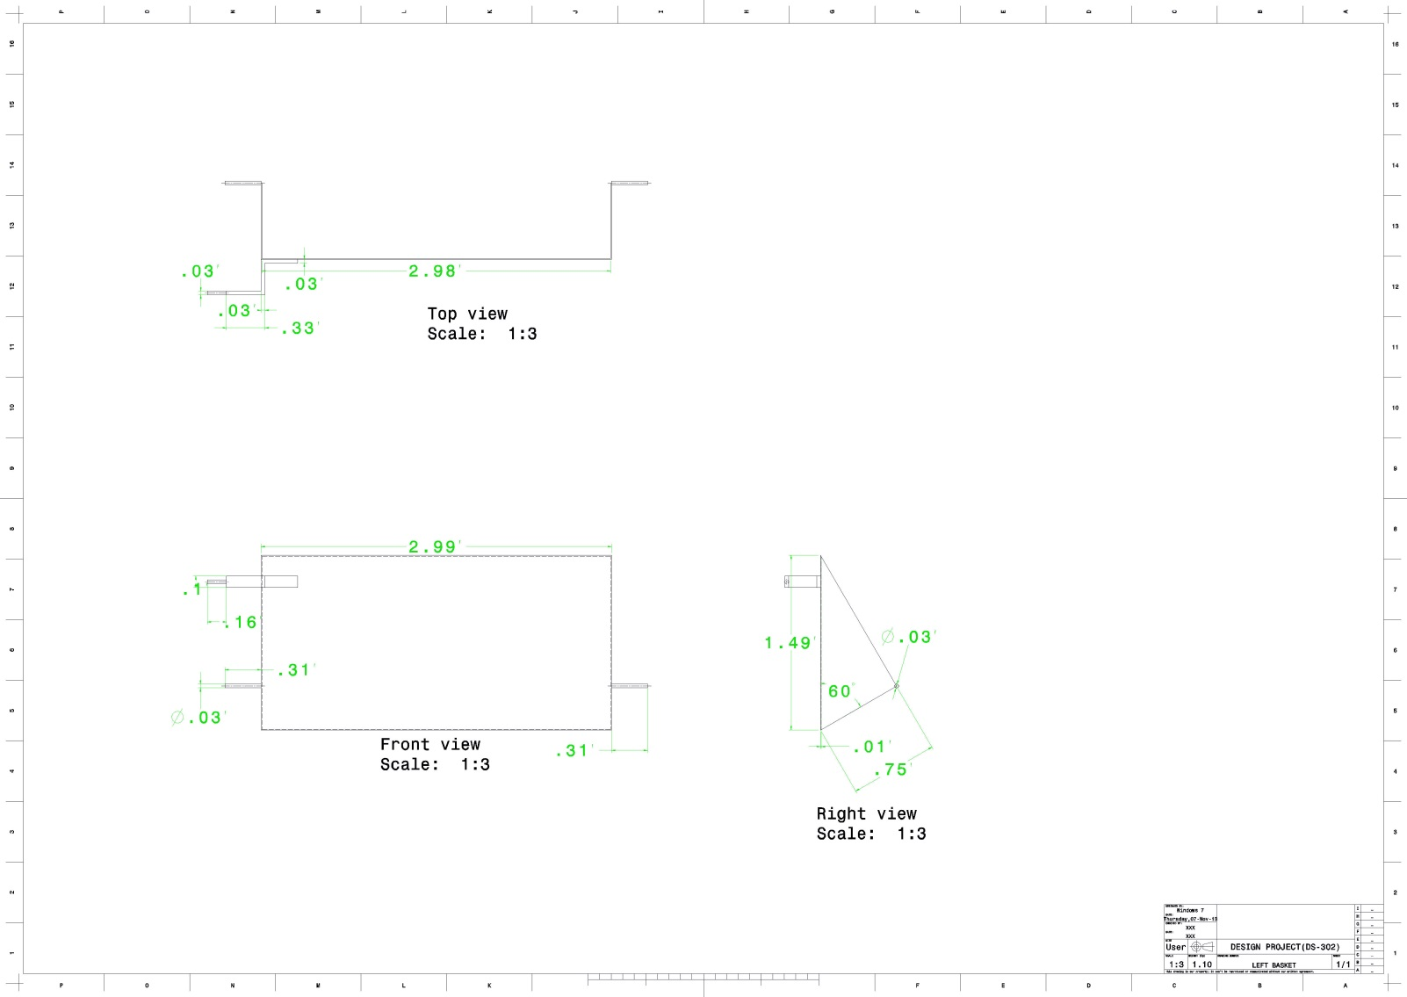

**Right Basket:-**

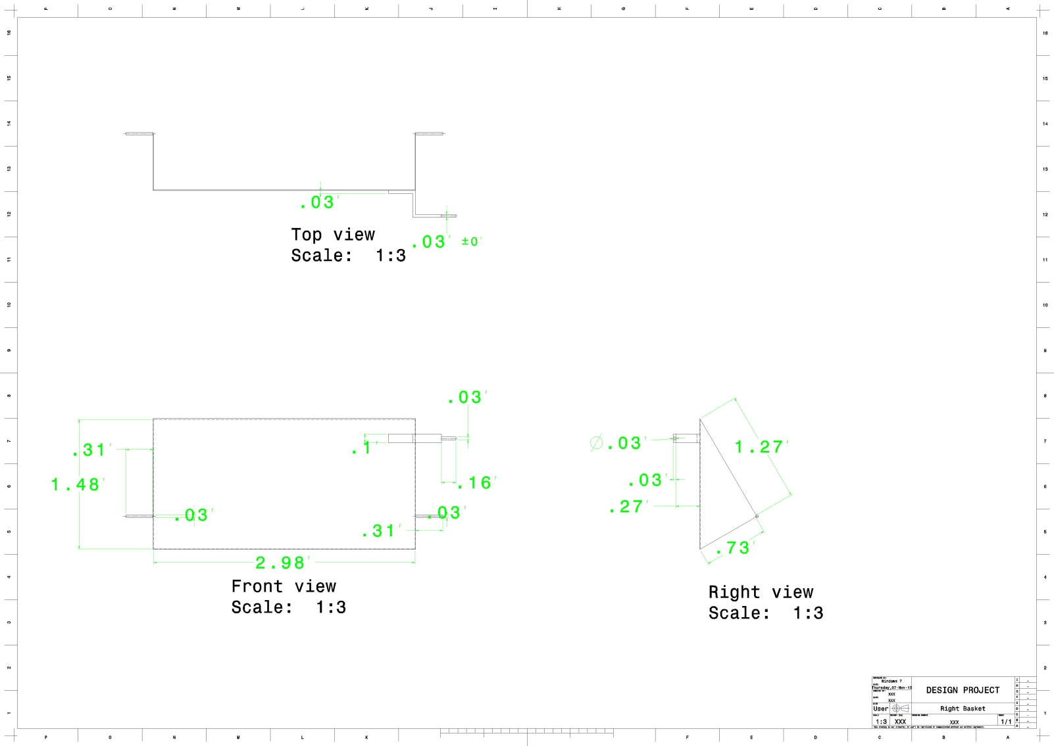

**Roof:-**

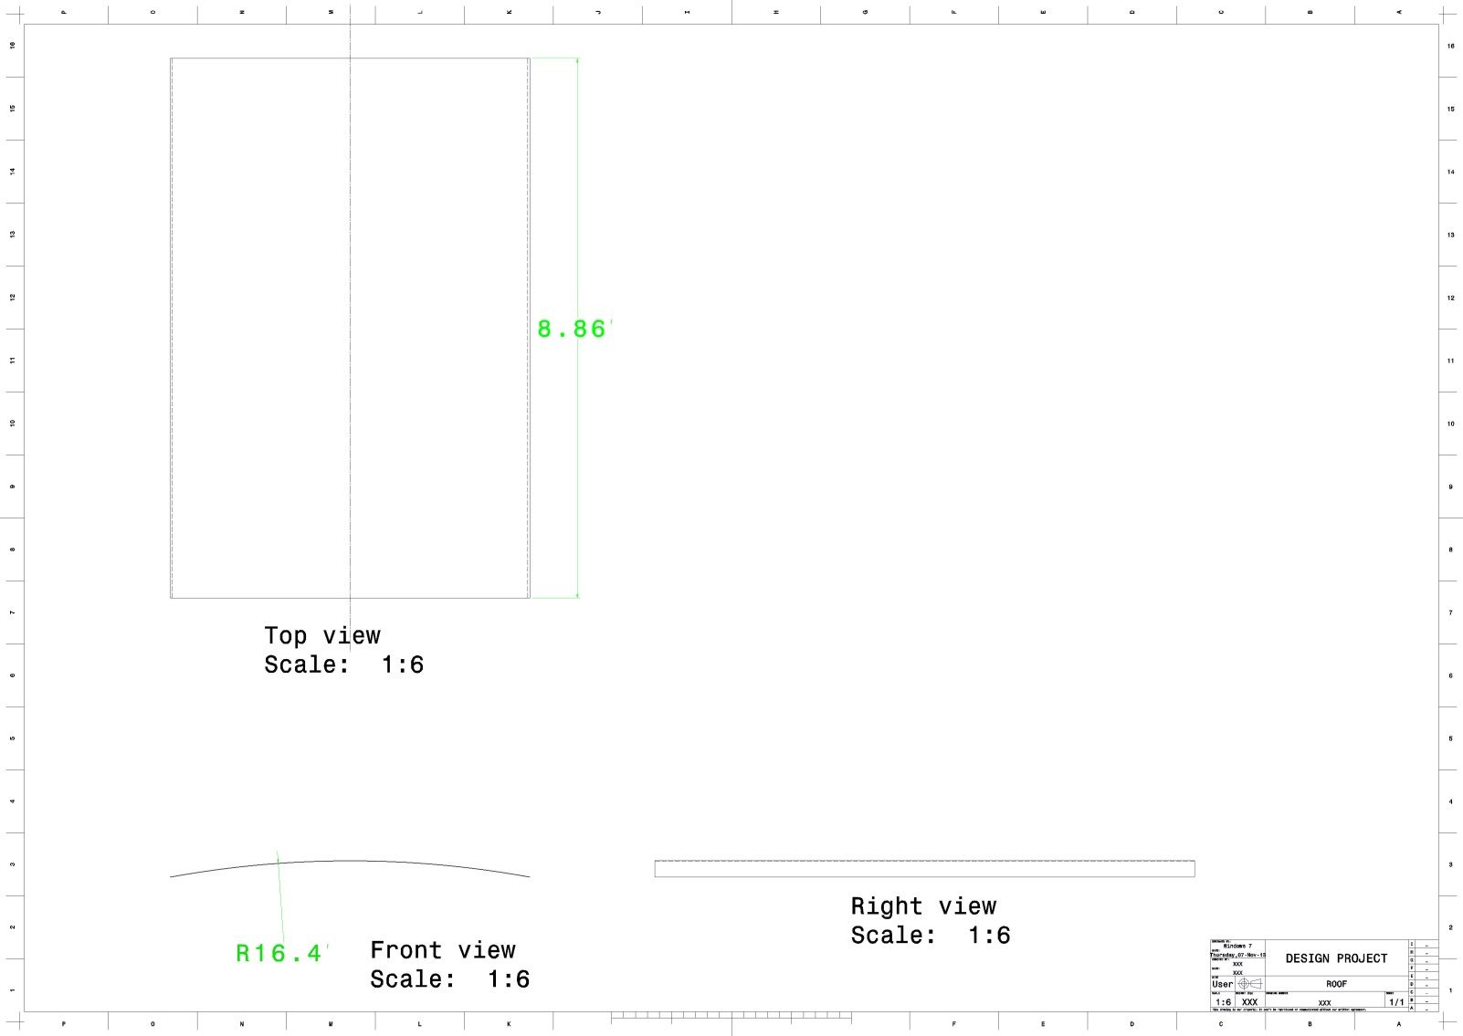

**Sensor Box:-**

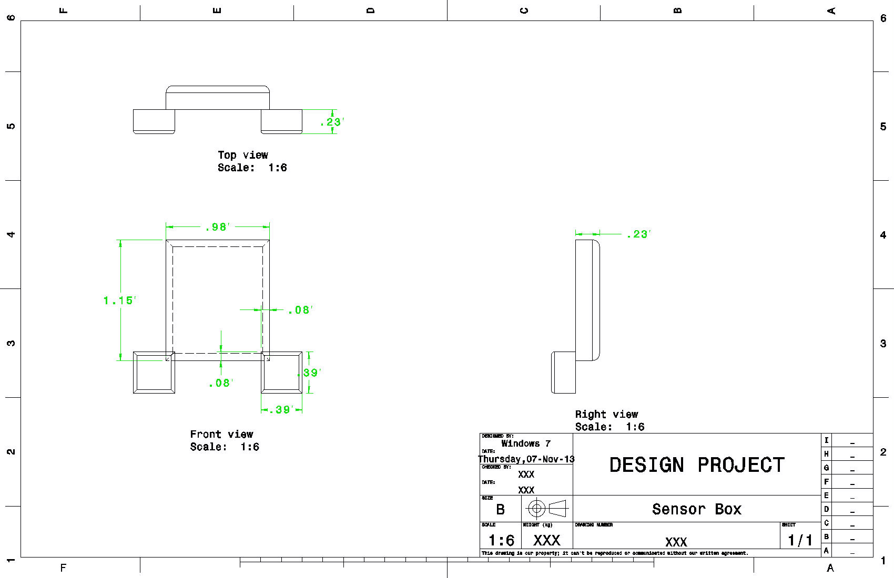

**Side Gate:-**

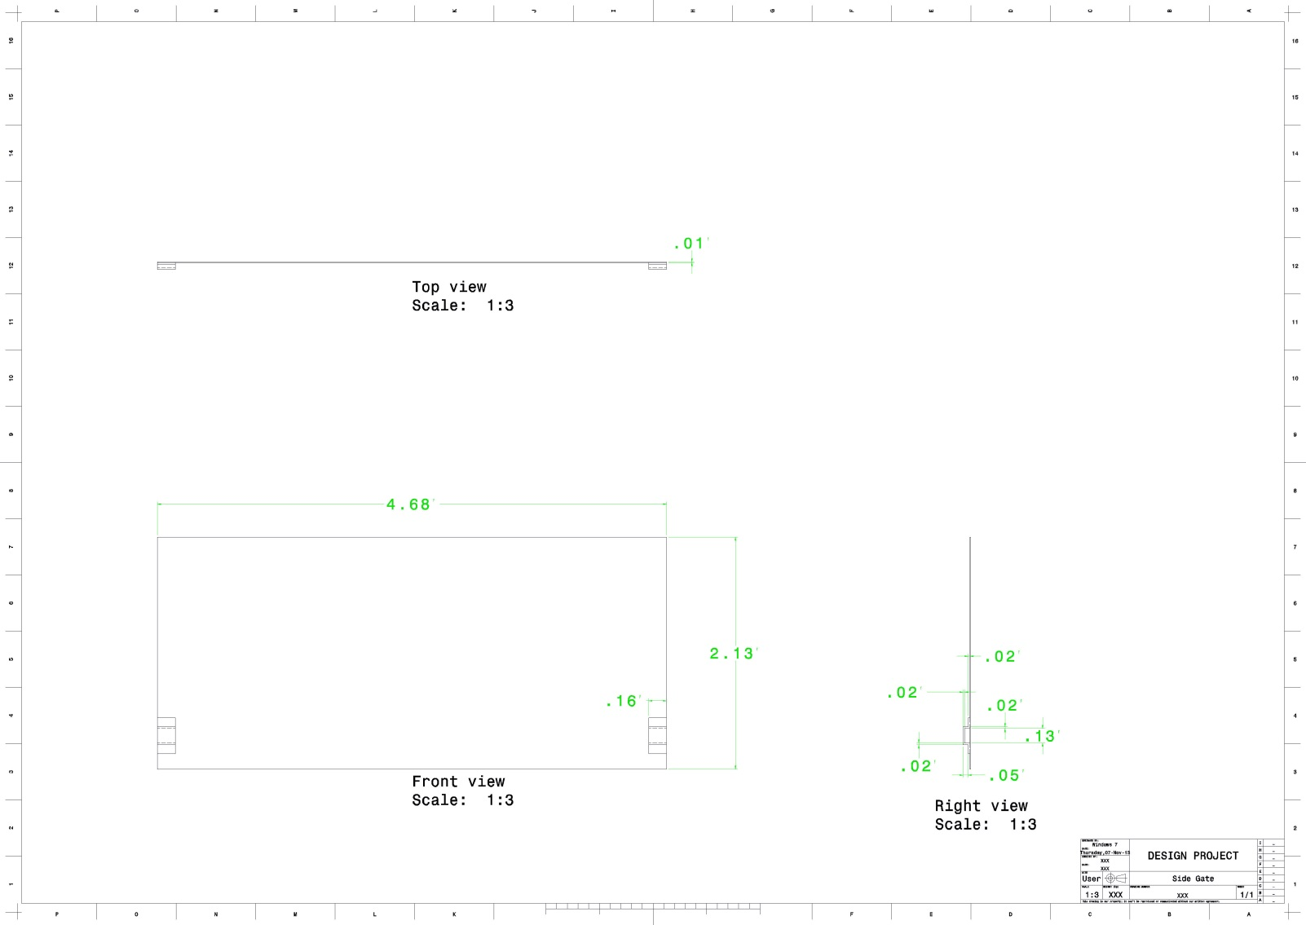

**Component specification:-**

1. Li-ion battery (2S)-8 volt, 200mA, full charge in 3-4 hours, 2000mAh

2. Hinge-length: 10 cm

3.Tsop sensor-5 volt,Range:30 cm

4.IR sensor-5 volt,Range:6 cm

5. Bearing-Ball Bearing 6201z, Bore Dia: 7 mm, Outer Dia: 20 mm

6. GSM module- SIM 900, 5 volt, UART Comm.

7. Rivets-Diameter: 5-10 mm

**Cost analysis:-**

**1.Cost of parts*:-***

|  |  |  |  |  |
| --- | --- | --- | --- | --- |
| S no | Parts | Quantity | Cost per part (in Rs.) | Total cost(in Rs.) |
| 1 | Geared Motor(30 rpm) | 2 | 250 | 500 |
| 2 | At mega -16 | 1 | 200 | 200 |
| 4 | Gsm Module Sim 900 | 1 | 1600 | 1600 |
| 5 | IR Sensor | 2 | 25 | 50 |
| 6 | Tsop Sensor module | 2 | 100 | 200 |
| 7 | L298 | 1 | 140 | 140 |
| 8 | 7805 | 1 | 15 | 15 |
| 9 | Register and capacitor (.1Uf)*10 | - | 10 | 10 |
| 10 | Long Burkstick | - | 50 | 50 |
| 11 | Switch | 2 | 5 | 10 |
| 12 | Adapter 12V | 1 | 150 | 150 |
| 13 | Female Burg stick | 1 | 6 | 40 |
| 14 | Make Burg stick | 1 | 4 | 40 |
| 15 | Resistor*10 (230 ohm) | 1 | 5 | 5 |
| 16 | Bearing | 4 | 30 | 120 |
| 17 | Small hinge | 6 | 30 | 180 |
| 18 | Big hinge | 2 | 60 | 120 |
| 19 | Nut and bolt and rivets | - | - | 100 |
| 20 | Aluminium sheet | - | - | 600 |
| 22 | Li-ion cell | 4 | 180 | 720 |
|  | TOTAL | - | - | 4861 |

**2. Cost of GI Sheet (garbage bin manufacturing):-**

Area of GI sheet =20.38 m2

Thickness= 1.5 mm

Volume of sheet=0.03057m3

Density=7850 kg/m3

Mass =240 kg

Cost of 1 kg = Rs. 45

Cost of sheet= Rs. 10800

**3. Manufacturing cost :-**

|  |  |  |  |  |  |
| --- | --- | --- | --- | --- | --- |
| S.no | Component | M/C cost per hour(Rs) | Labor cost per hour(Rs.) | Time taken | cost |
| 1 | PCB fabrication | 25 | 25 | 2 | 100 |
| 2 | Welding | 100 | 25 | 5 | 625 |
| 3 | Sheet cutting | 25 | 25 | 1 | 50 |
| 4 | Assembly | 100 | 25 | 2 | 250 |
| 5 | Total | - | - | - | 1025 |

Total cost =cost of parts +cost of GI sheet +Manufacturing cost

Total cost =4861+10800+1025 = Rs.16686

Since we are modifying existing design so in our project cost of garbage bin will not include.

Cost of total project = parts cost + PCB fabrication+ sheet cutting+ assembly

= 4861+100+50+250

Total cost= Rs.5201

**Ergonomics:-**

Ergonomics is the study of the interaction between people and machine or product and the factors that affect the interaction. Our product has been designed by considering the ergonomics issues related to the previous design. It is more compatible to the user than the previous as it has been automated to some extent facilitating ease to the user in throwing the garbage. Our design is fully covered, hence accomplishing its purpose. Anthropometry has been considered to design the basket so that garbage can be dumped in the bin without any discomfort to the user. Also ,Garbage Monitoring System has been implemented to check the garbage level, so that the workers and the administration are informed at the proper time and hence reducing the effort by minimizing their rounds to collect the garbage.

**Prototype:-**

**Circuit Diagram:-**

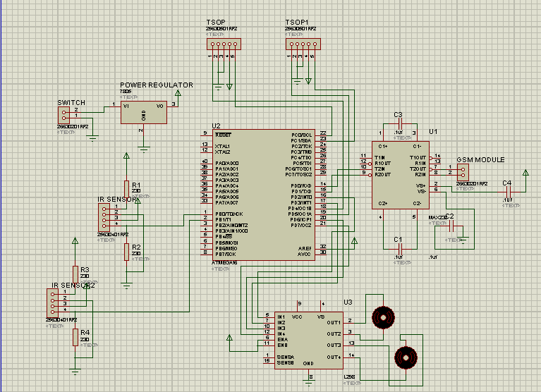

**3-D view:-**

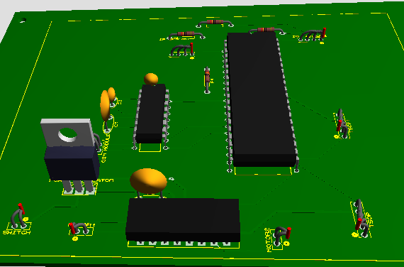

**Garbage bin parts assembly:-**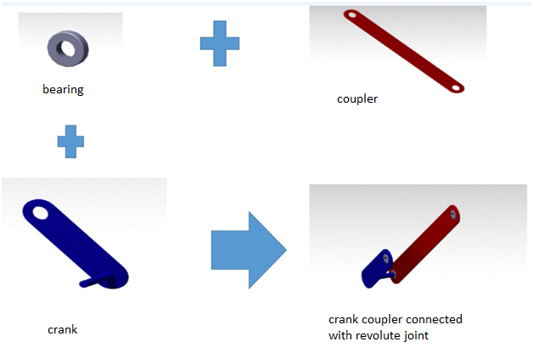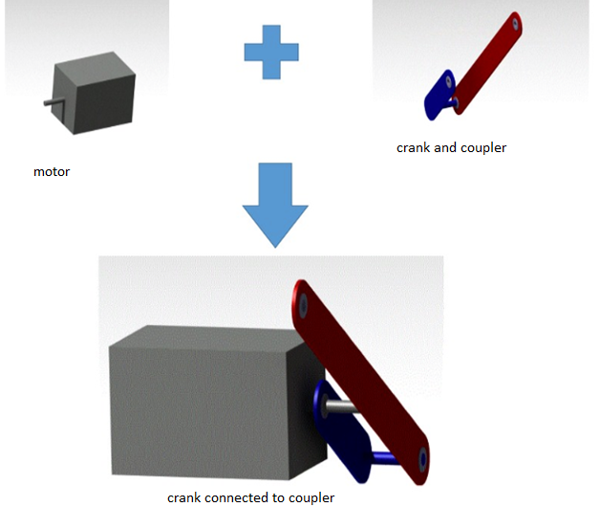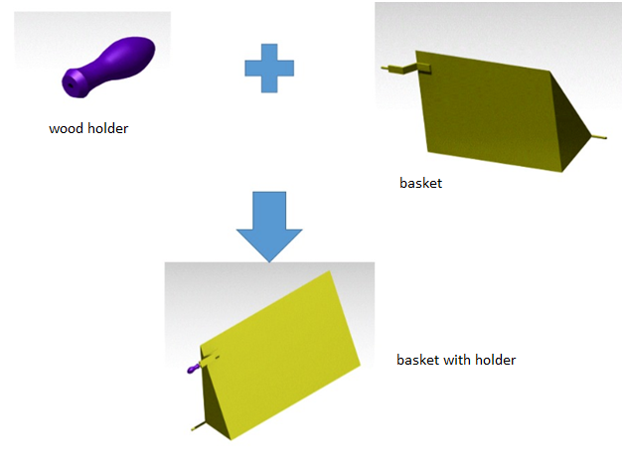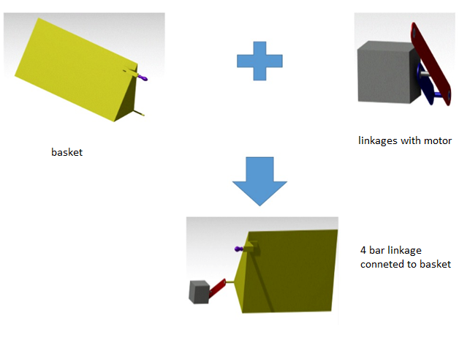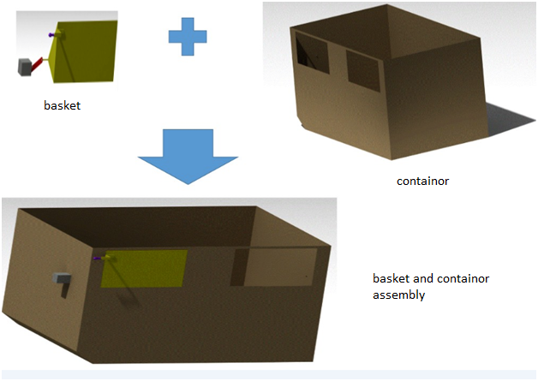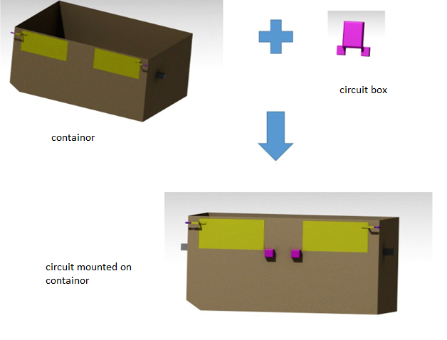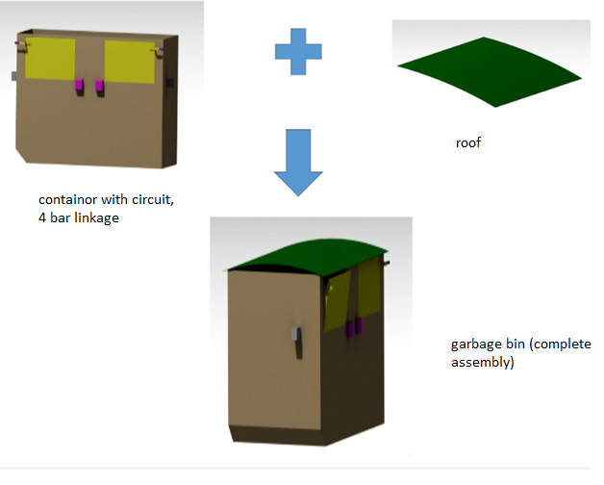

**Result:-**

1. After completely analysing the problem and getting the feedback from the survey of local people and head of Municipal Corporation we arrive at the conclusion of making the garbage bin which opens automatically when a person arrive nearby dustbin. It is user friendly.
2. To prevent overflowing of garbage a message is sent to supervisor when it is going to get full. If action is not taken within one day message is again send to supervisor and higher authority reducing man power and file work.
3. The dustbin is fully covered to prevent rain water getting filled which become breeding house for common flies and mosquitoes.

**Conclusion:-**

**1. Benefit:-**

1. Solve garbage overflowing by giving information to person responsible for garbage collection. .

2. Reduce manpower.

3. Fully cover design so rainwater cannot enter in dustbin. Avoid mosquito that prevent diseases.

4. Automatic opening, user friendly to users.

5. Prevent foul smell.

**2. Disadvantages:-**

1. Cost of dustbin will increase.
2. Inconvenience to user during power failure.
3. Power is required.
4. Garbage bin may open useless due to street animal.
5. Dependence of power can be eliminated by using solar power.

**Appendices:-**

1. Design can be improved

2. Dependence on power supply can be eliminated by using solar power.

3. It can be used in small scale.

**Vendors:-**

|  |  |  |
| --- | --- | --- |
| s.no. | Name | Address |
| 1. | Shankar hardware | Tularam chouk, Jabalpur |
| 2. | A. P. Enterprise | Naya mohalla, Jabalpur |
| 3. | R.P. Steel | Sadar |
| 4. | Shanker Hardware | Tularam Chouk. Jabalpur |
| 5. | Robomart | Online |
| 6. | Robosystems | Online |